Lab - Learning the Details of Attacks

Objectives
Research and analyze IoT application vulnerabilities.
Part 1: Conduct a Search of IoT Application Vulnerabilities

Background / Scenario
The Internet of Things (IoT) consists of digitally connected devices that are connecting every aspect of our lives, including our homes, offices, cars, and even our bodies to the internet. With the accelerating adoption of IPv6 and the near universal deployment of Wi-Fi networks, the IoT is growing at an exponential pace. According to Statista, industry experts estimate that by 2030, the number of active IoT devices will approach 50 billion.
However, IoT devices are particularly vulnerable to security threats because security has not always been considered in IoT product design. Also, IoT devices are often sold with old and unpatched embedded operating systems and software.

Required Resources
- PC or mobile device with internet access

Instructions

Conduct a Search of IoT Application Vulnerabilities
Using your favorite search engine, conduct a search for Internet of Things (IoT) vulnerabilities. During your search, find an example of an IoT vulnerability for each of the IoT verticals: industry, energy systems, healthcare, and government. Be prepared to discuss who might exploit the vulnerability and why, what caused the vulnerability, and what could be done to limit the vulnerability.
Note: You can use the web browser in the virtual machine that was installed in a previous lab to research security issues. By using the virtual machine, you may prevent malware from being installed on your computer.
From your research, choose an IoT vulnerability and answer the following questions:

Questions:
    - What is the vulnerability?
Type your answers here.
    - Who might exploit it? Explain.
Type your answers here.
    - Why does the vulnerability exist?
Type your answers here.
    - What could be done to limit the vulnerability?

Lab Answers
Part 1:
IoT vulnerabilities include weak credentials, Insecure update methods, Unencrypted device communications, physical attack surfaces, and insecure management interfaces.
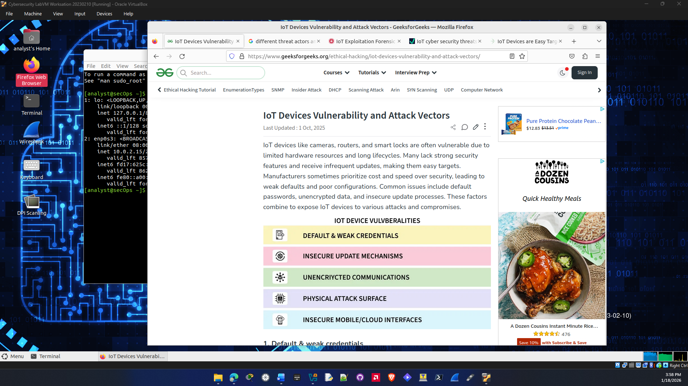

IoT Vulnerability Chosen: Unencrypted Communications

a. What is the vulnerability?
Unencrypted communications in IoT devices include any traffic whether that be Management, telemetry, or API traffic that is sent over the network without encryption or weak cryptography. Something like this would be using no TLS or DTLS to secure internet communications. Since cryptography might not be used sensitive information is transmitted in plaintext and this can be intercepted. If they do this attackers can steal that intercepted data and gain unauthorized access into devices which then can turn into an attack point for malicious command injections to hijack the device sessions. This can lead to the whole network being compromised and every other device connected to that network vulnerable. Some common IoT devices that might be exploited in this way are smart security system, smart thermostats, Industrial sensors for monitoring, Smart Traffic Lights, and Smart Water management. The attack vector chosen for this vulnerability is Man-in the-middle / eavesdropping. Where they intercept credentials and manipulate commands to hijack devices.

b. Who might exploit it? Explain.
There are many threat actors that might exploit this type of data depending on the setting and where the IoT device is used. If the device attacked was in a government office then it could be a state sponsored attack trying to gain access to government information. Organized cybercriminals could also try exploiting IoT for financial gain. They can do this through ransomware or data theft. It could also be Inexperienced attackers using an existing tool to try and gain access into someone’s home devices and steal passwords or other sensitive information. An insider threat could also exploit IoT devices since they could have knowledge of the network and what devices they could potentially exploit that are connected to that network.

c. Why does the vulnerability exist?
A big reason why this vulnerability exists is because a lot of IoT devices are now created by the cheapest means possible. This also includes the firmware that is installed on the device. There is generally no accepted security standard in the IoT industry. Device security is obviously not a priority in the manufacturing process. Little to no security testing is performed on IoT devices before the device is shipped out to the client. Also, multiple devices may be using the same firmware because of this leading to multiple devices with these vulnerabilities on your network. A lot of IoT devices are also equipped with weaker hardware to cut costs so sometimes using advanced encryption methods might not be possible on a lot of these devices. Many IoT devices are also not designed to be easily patched or updated or they just outright can’t be restarted since the impact would be too critical. For example things like equipment sensors in power plants are vital for the operation of the plant and taking them offline would cause critical issues.

d. What could be done to limit the vulnerability?
There are many ways you can limit weak encryption. One of the main ways to limit the impact is through network segmentation. This is actually a method I use for my IoT devices at home but putting your IoT devices on a separate network or subnet / vlan prevents communication to other devices on a network which will limit the impact of a compromised device. Implementing stronger forms of authentication into IoT networks can also limit this vulnerability. Implementing Multi factor authentication access to the IoT network adds an extra layer of security making it harder to breach. This can also be extended to using firewalls and Intrusion detection systems to make it even harder to gain access to IoT networks. If possible keep your IoT device firmware up to date to make sure it’s updated with the latest security patches. As a last resort if your devices can not be secured in a lot of these ways then heavy monitoring of your IoT devices should be used to limit this vulnerability.

Sources:
https://www.geeksforgeeks.org/ethical-hacking/iot-devices-vulnerability-and-attack-vectors/
https://www.lrqa.com/en/insights/articles/iot-cyber-security-threats-how-cybercriminals-target-iot/
https://asimily.com/blog/iot-devices-are-easy-targets-for-cyberattacks/

End of document

